Experiment 2
Client–Server Communication Between Two Virtual Machines

Assign/check the IP address of both VMs.
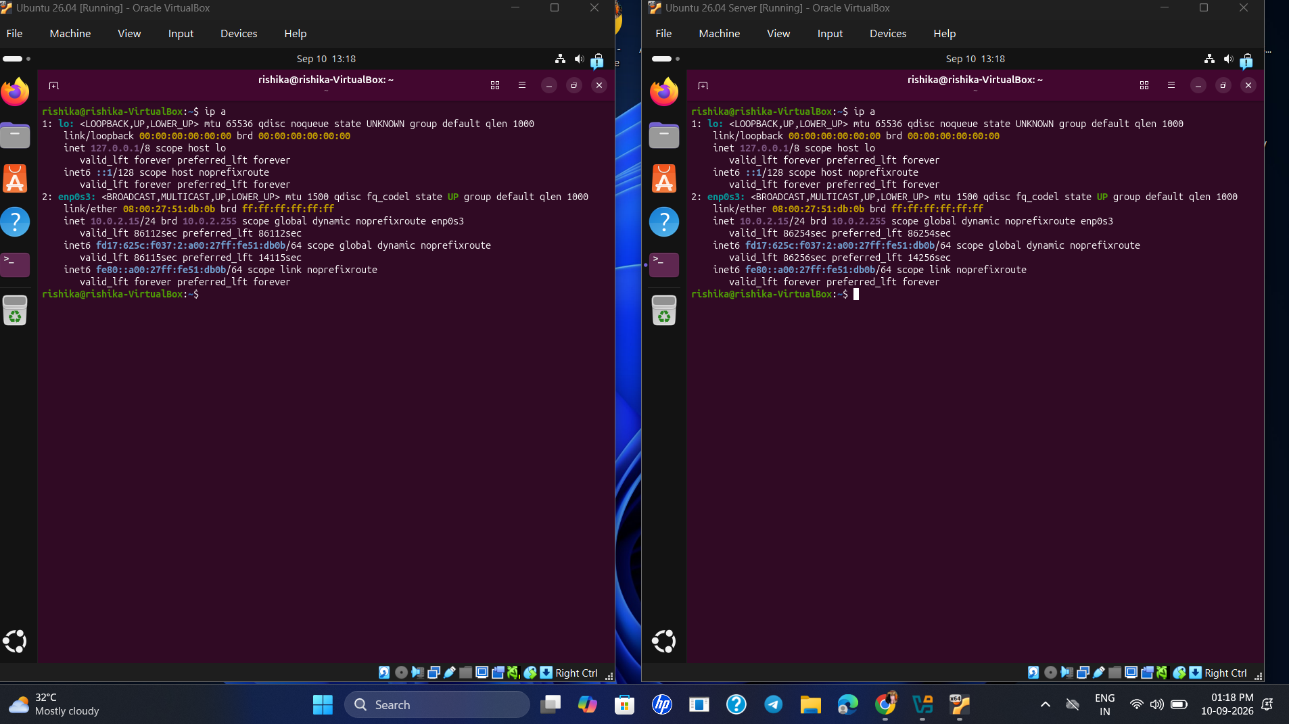

Configure both VMs on the same virtual network.
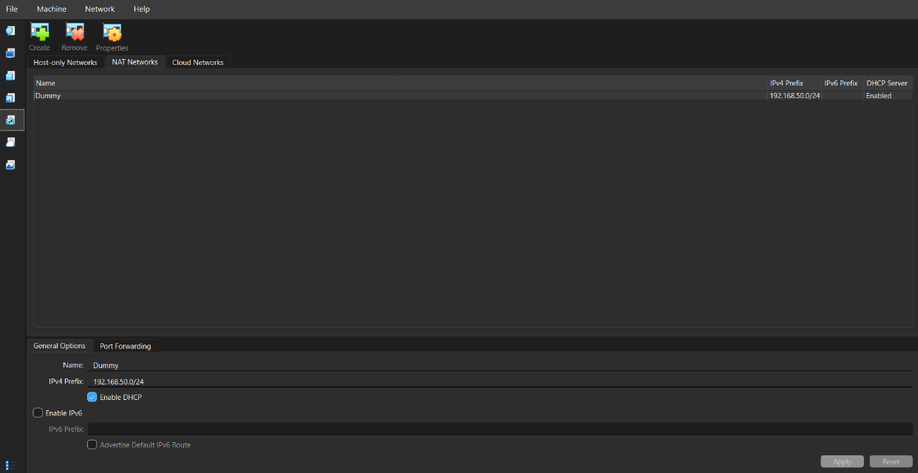
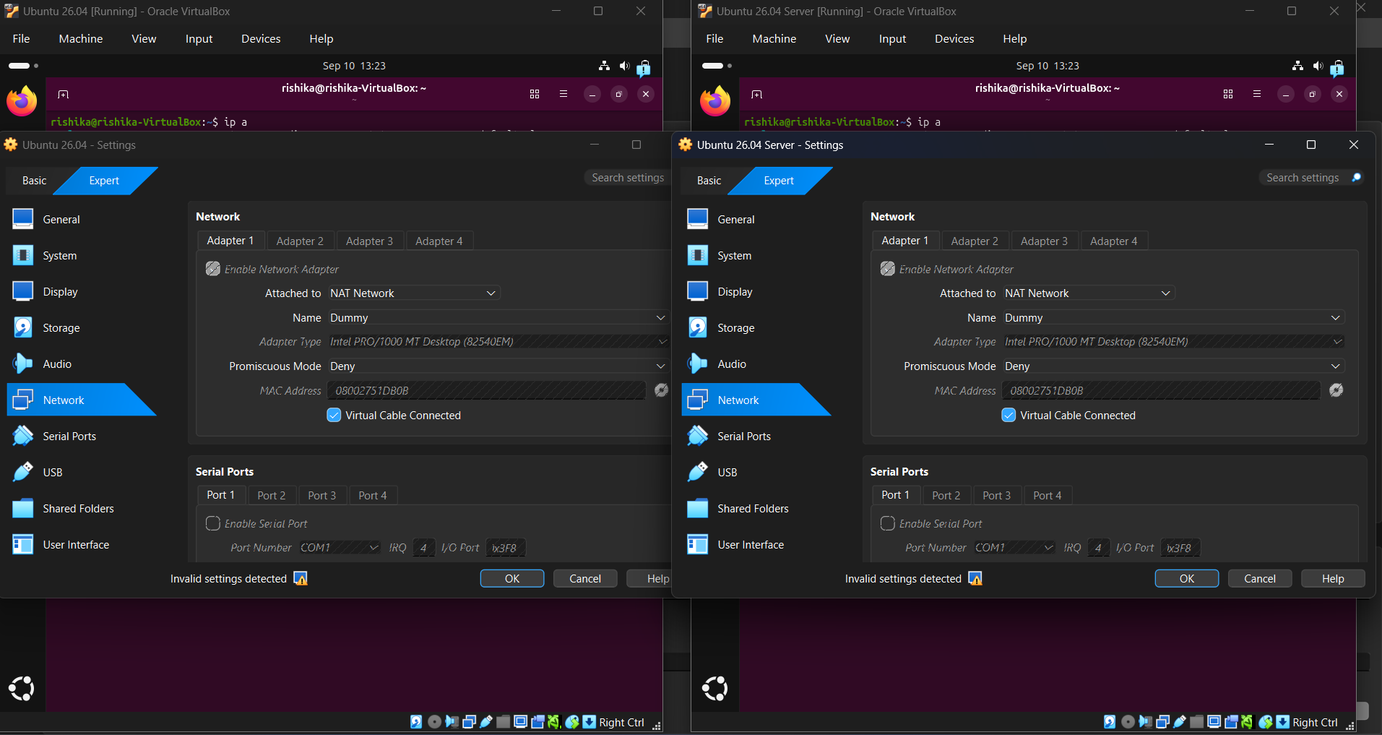

Test connectivity using the ping command.
